Order Number: 01-29018-002
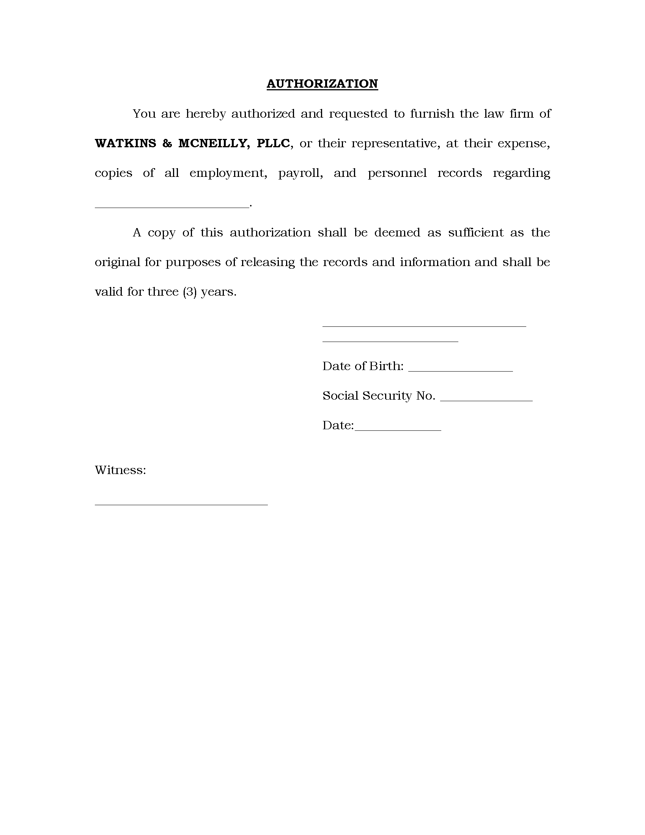
Batman
xxx-xx-5555
01/01/1979
2869 Jolly Rd
Okemos, MI 48864
Phone: 877-886-5090 Fax: 517-886-4116
Axiom Requisition
at 2869 Jolly Rd Okemos, MI 48864

